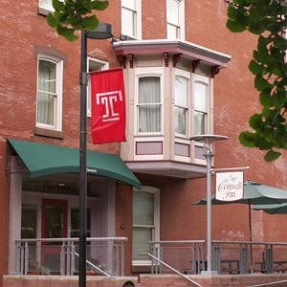
Conwell Inn: (215) 235-6200
Cost: $134 per night + tax
Address: 1331 W. Polett Walk, Philadelphia, PA 19122
Distance: 2 miles
- Parking: $15 per night (reserve ahead of time)
- Located on Temple University’s Campus
- Close to many quick restaurants and coffee shops
- Closest Hotel to Temple University Hospital
- Free Wi-Fi
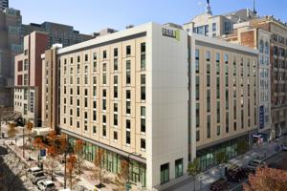
Home2 Suites: (877) 646-6302
Cost: $139 per night + tax
Address: 1200 Arch Street. Philadelphia, PA 19107
Distance: 3.7 Miles
- Complimentary Breakfast, Free WIFI, Indoor pool
- Pet Friendly

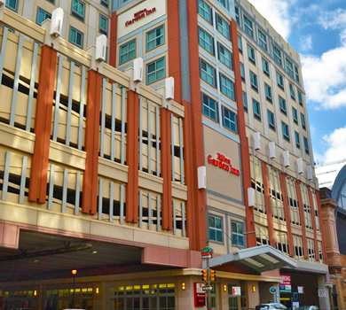
Hilton Garden Inn: (215) 923-0100
Cost: $155 per night + tax
Address: 1100 Arch St, Philadelphia, PA 19107
Distance: 4 miles
- Parking: $35 Per Night
- Complimentary Wi-Fi, Fitness & Business Center
- Nearby to Philadelphia’s Historical Sites
- Adjacent to Reading Terminal Market

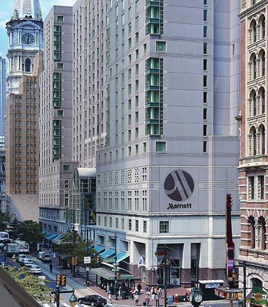
Philadelphia Marriott Downtown: (215) 625-2900
Cost: $149 per night + tax
Address: 1201 Market St, Philadelphia, PA 19107
Distance: 4 miles
- Parking: $49 per night (Valet)
- Restaurants on site
- Across from Reading Terminal Market
- Connected to Pennsylvania Convention Center
- Please mention NON-GROUP RESERVATION

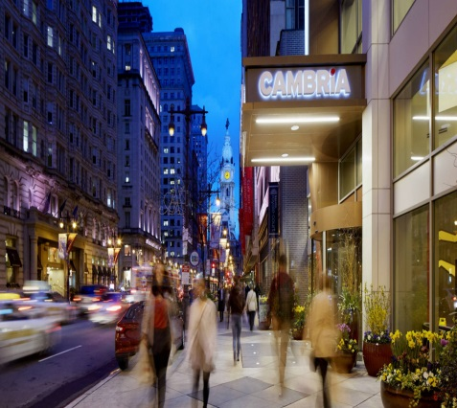
Cambria Philadelphia Hotel: (215) 732-5500
Cost: Hospital Rate for Temple 20% discount
Temple Discount at Cambria Philadelphia Hotel
Address: 219 S Broad St, Philadelphia, PA 19107
Distance: 4.2 miles
- Parking: Valet only $45
- Complimentary Wi-Fi, 24 hour Fitness Center
- Equipped with microwave, refrigerator
- Several on-site dining including a roof top restaurant

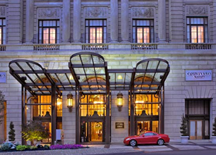
Courtyard Philadelphia Downtown: (215) 496-3200
Cost: $166 per night + tax
Address: 21 North Juniper Street, Philadelphia, PA 19107
Distance: 4.2 miles
- Parking: Valet only $44 + tax per night; $28 for the day
- Free Wi-Fi, Fitness Center
- On site Laundry
- Nearby to City Attractions & Restaurants
  - Reading Terminal Market, 13th Street

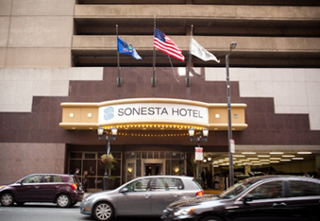
Sonesta Hotel: (215) 561-7500
Cost: $145 per night Temple University Hospital Rate
Address: 1800 Market Street, Philadelphia, PA 19103
Distance: 4.3 miles
- Parking: 50% Off overnight valet parking
- Free Wi-Fi, and Fitness Center
- Complimentary Access to Sports Club
- Access to Public Transportation
- Nearby Restaurants
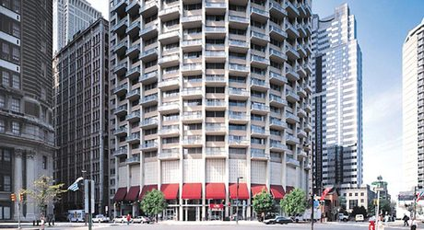
Windsor Suites Philadelphia: (609) 405-2588 CODE: TEMPLE
Cost: $139 per night + tax The Windsor Suites – Temple Hospital Rate
Address: 1700 Ben Franklin Parkway, Philadelphia, PA 19103
Distance: 4.3 miles
- Complimentary Wi-Fi
- Full Equipped Kitchen
- Seasonal Roof-Top Pool
- Two On-Site Restaurants
- On site car Rental

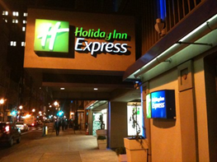
Holiday Inn Express: (215) 735-9300
Melissa Berrios - Sales Manager (215)732-1045
Cost: $134 per night + tax
Address: 1305 Walnut Street, Philadelphia, PA 19107
Distance: 4.4 miles
- Parking: $30 per night (Self-Park)
- Free Wi-Fi and Breakfast Bar
- Complimentary breakfast
- Walking Distance to Reading Terminal Market
- Fitness Center + Washer and Dryer

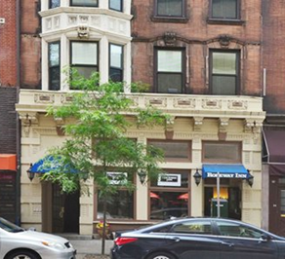
Rodeway Inn: (215) 546-7000
Cost: 10% discount
Address: 1208 Walnut Street, Philadelphia, PA 19107
Distance: 4.4 miles
- $15/ day Parking
- Complimentary Wi-Fi Services
- Nearby Restaurants

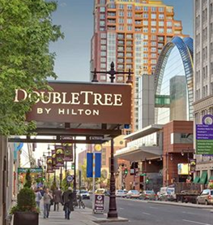
Double Tree Hotel: (215) 893-1600
Cost: $165 per night + tax
Address: 237 South Broad Street, Philadelphia, PA 19107
Distance: 4.7 miles
- Parking: $28 per night (Self) / $42 per night (Valet)
- Complimentary Wi-Fi in Hotel Lobby
- Selection of Restaurants within Walking Distance

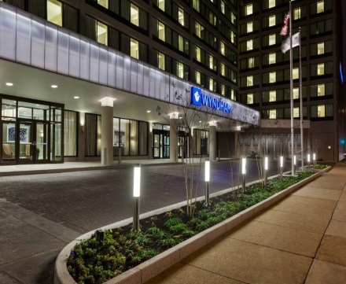
Wyndham Philadelphia: (215) 923-8660
Cost: $116 per night + tax
Address: 400 Arch Street, Philadelphia, PA 19106
Distance: 4.8 miles
- Parking: $5 per night (Hospital rate)
- Free Wi-Fi, Seasonal Pool, & Fitness center
- Within walking distance to Historic District

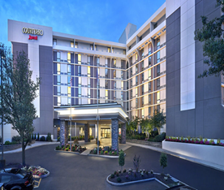
Courtyard Marriott Philadelphia City Ave: (215) 477-0200
Cost: $144 per night + tax www.marriott.com/phlav Code: TU3
Address: 4100 Presidential Blvd. Philadelphia, PA 19131
Distance: 5 miles
- Free Parking, Wi-Fi and 24 Hour Business Center
- Fitness Center and Indoor Pool
- Lobby Bistro and 24-Hour Marketplace
- Multiple Restaurants and Grocery store adjacent

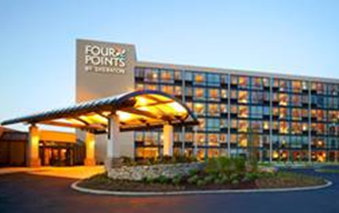
Four Points Sheraton: (215) 671-9600
Cost: $91 per night
Bessie Valentin: Senior sales Manager
Address: 9461 Roosevelt Blvd, Philadelphia, PA 19114
Distance: 9.6 miles
- Free Parking & Complimentary Wi-Fi
- Fitness Center, & Business Center
- Heated Salt Water Indoor Pool
- Local Dining Options, Supermarket
- Retail shopping within walking distance

LONG TERM STAYS
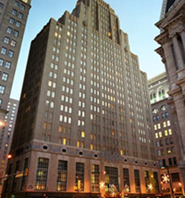
Marriott Residence Inn: (215) 557-0005 ext. 4401
Cost: Based on length of stay
Address: 1 East Penn Square, Philadelphia, PA 19107
Distance: 4.1 miles
- 5 Star Parking Garage Nearby - $27 per night self/ $51 Valet
- Free Wi-Fi, Meeting Space, & Onsite Laundry Facilities
- Social Hour w/ Food for All Guests (3x a week)
- Walking Distance to Restaurants

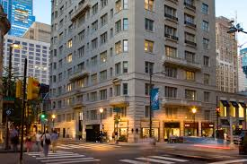
AKA Rittenhouse: (215) 825-7000
Cost: Based on length of stay
Address: 135 S 18th St, Philadelphia, PA 19103
Distance: 4.2 miles
- Parking: $20 per night
- Located in beautiful Rittenhouse Square
- Ideal for long term stays
- Suites fully furnished with full kitchens

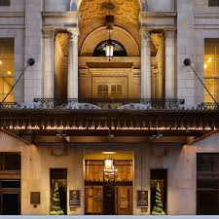
The Franklin Residencies: (610) 212-8975
Cost: $115-155 for 1 Bedroom: $180-205 for 2 Bedrooms
Address: 834 Chestnut Street, Philadelphia, PA 19107
Distance: 4.3 miles
- Parking: $11 per night
- Located right of Washington Square Park
- Includes Welcome Grocery Package, WiFi & Fitness Center
- Spacious fully furnished suites w/ full kitchen & washer/dryer
- Close to many restaurants, bars and shops

*ALL PRICES SUBJECT TO CHANGE

